Updating Templates after changing the Master Library

Written By: | RAB | Creation Date: | 11/05/07
Reviewed By: |  | Last Revised: | 11/05/07
Project: | PGSuper | WI # | <<#>>
 |  | Version | 1.0 - Draft

Purpose
This work instruction will describe how to, more or less, automatically update all your template files after changes have been made to the Master Library.

Once the Master Library has been changed, the library entries stored in the template files are out of date. Each time you create a new project using these template files the user will be prompted with a Library Conflict message.

To update your templates, you must create a new project for each template, overwrite the old library entries with the new ones, and export the project as a template. This is a very time consuming process, but can be expedited using a “hidden” feature in PGSuper.

Procedure
The basic procedure is explained below. The following assumptions are made about the name and location of the master library file and the templates folder. You’ll have to adjust according to your specific situation.

Master Library File: C:\PGSuper.lbr
Workgroup Template Folder: C:\PGSuperTemplates

The basic procedure is as follows:
- Using the library editor program, make all your modifications to the various library entries. (Edit the C:\PGSuper.lbr file – or whatever your file is)
- Configure PGSuper to use the Master Library File and Templates that need to be updated
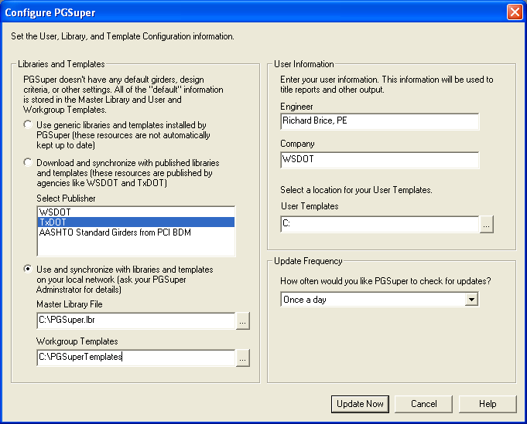
- When the Update Now button is pressed the library and template caches will be updated.
- Press Alt+Ctrl+U to cause PGSuper to automatically update the template files. PGSuper will open every template file, overwrite all the library entry conflicts and export the result project as a new template. The updated templates will be stored in the workgroup template cache.
- Copy the updated templates from the workgroup template cache (usually in C:\Documents and Settings\<user>\Application Data\PGSuper\WorkgroupTemplates) to the Workgroup Templates folder (C:\PGSuperTemplates for this example)
- Copy the updated master library file and workgroup templates to the FTP server so everyone can use them.

